***60 Sessantanni Limited Edition***

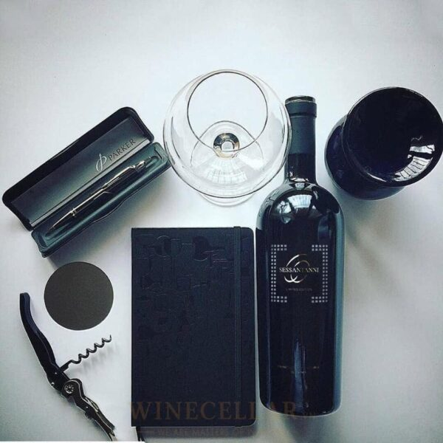

*"Mentioning 60 Sessantanni is referring to the difference in aroma and taste. No need to enjoy, right from the moment you open the bottle you are conquered by the passionate and seductive aroma of the wine. That scent has the ability to impress and have a strong impact on the sense of smell like an invitation that makes you unable not to enjoy.  
  
And when you take small sips on your lips, all your senses are awakened and you feel that this is really the best Italian wine."*